Understanding Search Functionality

**Introduction**

-> The product team is most interested in determining whether they should even work on search in the first place and, if so, how they should modify it.

Link for more details: <https://mode.com/sql-tutorial/understanding-search-functionality>

My approach will be as follows, find out:

* How much the search function is used vs every other function in the yammer website, the goal is to quantify how important the search function is.
* The percentage of search results found via auto complete vs the results page, the goal is to understand how effective is the autocomplete function.
* The percentage of the different click results in the result page, the goal is to be able to optimize the result feature more and find out more about user behavior.

**Part 1: Search Function Usage Compared to Other Events**

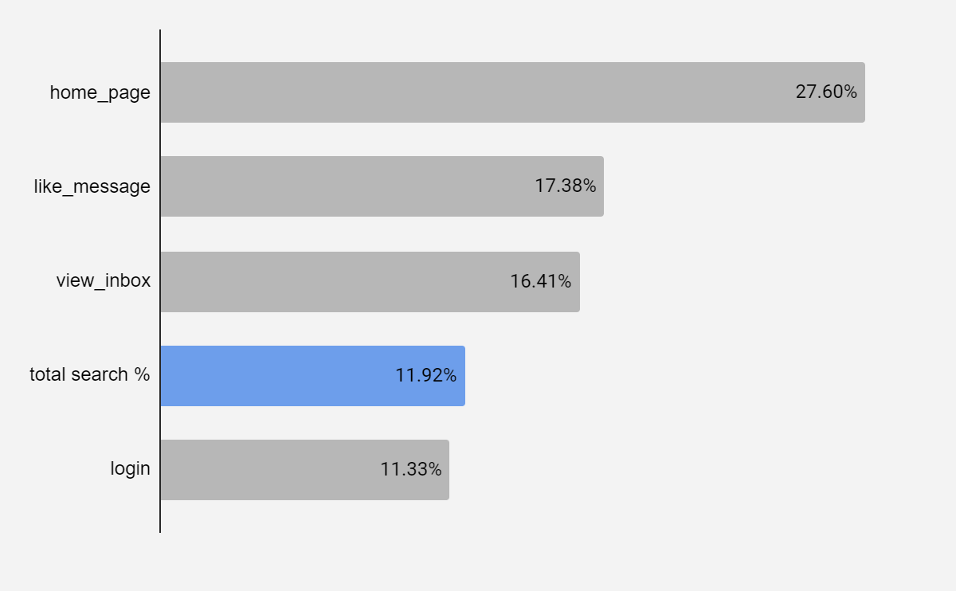

Figure. 1. Top 5 events percentage from yammer_events table

In the figure above, total search % reflects the usage of all different search functions from the events table. As we can see, it ranks 4th in terms of user engagement, making it a key feature that users rely on frequently. Further optimizing this feature could greatly enhance the user experience for a significant portion of our audience.

**Part 2: Percentage of Users Finding Results via Search Autocomplete (search_autocomplete) vs. Results Page (search_run)**

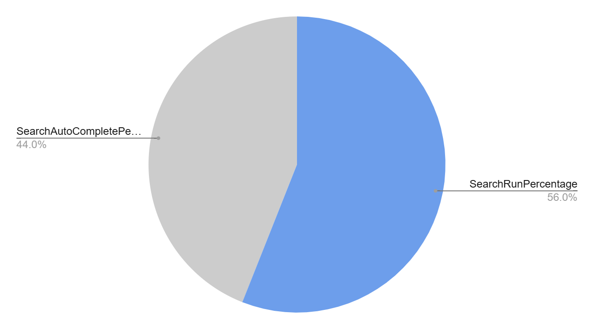

Figure. 2. Percentage of usage for the two different search functions

Figure 2 shows the usage percentages for the autocomplete and results page functions, which are nearly equal at around 50/50. This close split suggests that the autocomplete function may not be as effective as intended, as users often need to rely on the results page to find what they're looking for. Improving autocomplete accuracy could help users find results more quickly and reduce their dependence on the full results page.

**Part 3: Percentage of All Different search_click_result_%**

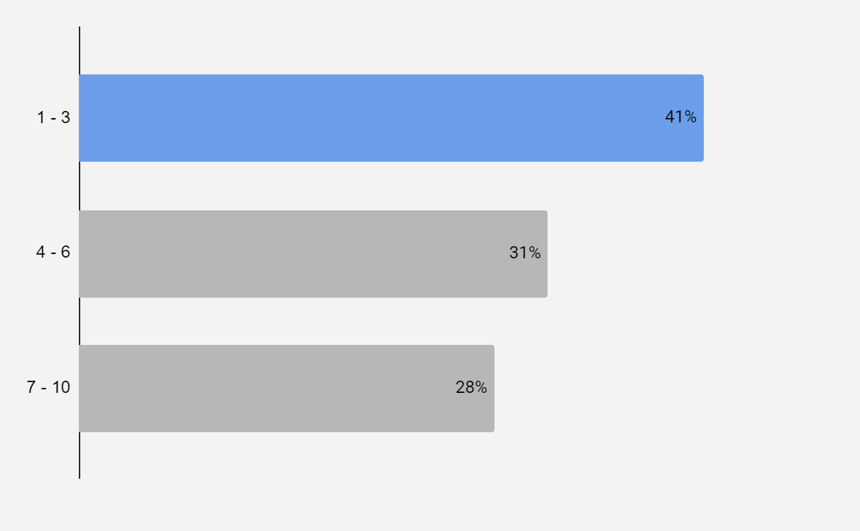

Figure. 3. Percentage of the click results from yammer_events table

In Figure 3, we see the percentage distribution of clicks on search results by users, grouped into three sets: results 1–3, 4–6, and 7–10. The lower the number, the quicker users find their desired result. Notably, 41% of the time, users click within the first three results, indicating relatively efficient searches. However, in more than half of cases, users need to scroll to find what they’re looking for. This suggests that improving result relevance within the top few positions could streamline the search experience, helping users find what they need faster.

**Conclusion**

Our analysis shows that the search function is essential for Yammer users. Most often, users rely on the results page rather than autocomplete, and while they typically find what they’re looking for within the first three results, about half the time they have to scroll further.

Optimizing the search function is clearly worthwhile, as it’s widely used and enhancing user experience should be a top priority. Key recommendations include:

* **Enhance the Autocomplete Feature**: Boost its usage to cover more than half of searches by ensuring frequently searched terms are recognized and that keyword relevance is optimized.
* **Refine the Results Page**: Minimize the need for excessive scrolling so users can find results quickly within the top few entries.
* **Analyze User Patterns**: Examine if users repeat the same search queries and how often they refine their searches, providing insights to further tailor search functionality.

Part 1:

SQL code:

| **SELECT event_name AS event,**  **COUNT(*) AS InstanceCount**  **FROM tutorial.yammer_events**  **GROUP BY event_name;** |
| --- |

Table:

| **event** | **instancecount** |
| --- | --- |
| complete_signup | 3680 |
| create_user | 7298 |
| enter_email | 4407 |
| enter_info | 3872 |
| home_page | 94065 |
| like_message | 59248 |
| login | 38610 |
| search_autocomplete | 17820 |
| search_click_result_1 | 1413 |
| search_click_result_10 | 506 |
| search_click_result_2 | 1499 |
| search_click_result_3 | 1134 |
| search_click_result_4 | 1264 |
| search_click_result_5 | 968 |
| search_click_result_6 | 805 |
| search_click_result_7 | 709 |
| search_click_result_8 | 690 |
| search_click_result_9 | 784 |
| search_run | 13019 |
| send_message | 33105 |
| view_inbox | 55936 |

Part 2:

SQL code:

| **SELECT**  **SearchRunCount.SearchRun,**  **SearchAutoCompleteCount.SearchAutoComplete,**  **(SearchRunCount.SearchRun + SearchAutoCompleteCount.SearchAutoComplete) AS TotalSearches,**  **(CAST(SearchRunCount.SearchRun AS FLOAT) /**  **(SearchRunCount.SearchRun + SearchAutoCompleteCount.SearchAutoComplete)) * 100 AS SearchRunPercentage,**  **(CAST(SearchAutoCompleteCount.SearchAutoComplete AS FLOAT) /**  **(SearchRunCount.SearchRun + SearchAutoCompleteCount.SearchAutoComplete)) * 100 AS SearchAutoCompletePercentage**  **FROM**  **(SELECT COUNT(event_name) AS SearchRun**  **FROM tutorial.yammer_events**  **WHERE event_name LIKE 'search_run'**  **OR event_name LIKE 'search_click_result_%') AS SearchRunCount,**  **(SELECT COUNT(event_name) AS SearchAutoComplete**  **FROM tutorial.yammer_events**  **WHERE event_name = 'search_autocomplete'**  **) AS SearchAutoCompleteCount** |
| --- |

Table:

| SearchRunPercentage | SearchAutoCompletePercentage |
| --- | --- |
| 56% | 44% |

Part 3:

SQL code:

| **SELECT event_name AS SearchX,**  **COUNT(*) AS InstanceCount**  **FROM tutorial.yammer_events**  **WHERE event_name LIKE 'search_click_result_%'**  **GROUP BY event_name;** |
| --- |

Table:

| **searchx** | **instancecount** |
| --- | --- |
| search_click_result_1 | 1413 |
| search_click_result_10 | 506 |
| search_click_result_2 | 1499 |
| search_click_result_3 | 1134 |
| search_click_result_4 | 1264 |
| search_click_result_5 | 968 |
| search_click_result_6 | 805 |
| search_click_result_7 | 709 |
| search_click_result_8 | 690 |
| search_click_result_9 | 784 |